ASSIGNMENT NO. 1: Introduction to Databases and SQL Environment
Name: Vedanti Santosh Shinde
Roll.no:21000
Questions:
Q1) Write SQL commands to create a database named SchoolDB.
The program should:
1. Create a new database named SchoolDB.
2. Select the database for use.
3. Display confirmation by creating a simple table inside it.
ANS:
query: CREATE DATABASE SchoolDB;
USE SchoolDB;
CREATE TABLE TestTable (ID INT);
output screenshot:
Q2) Create a table named Student with the following columns:
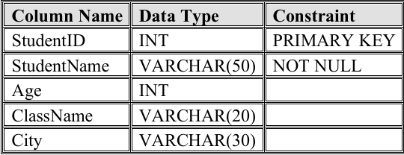
The program should:
1. Create the table.
2. Define proper data types.
3. Apply primary key on StudentID.
ANS:
Query:
USE SchoolDB;
CREATE TABLE Student (
StudentID INT PRIMARY KEY,
StudentName VARCHAR(50) NOT NULL,
Age INT,
ClassName VARCHAR(30)
City VARCHAR(20));
Output Screenshot:
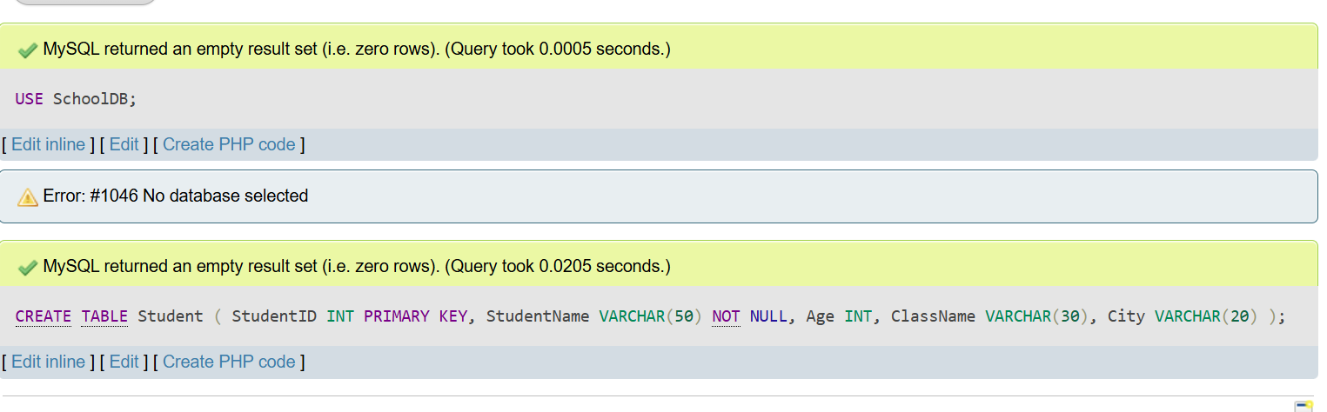
Q3) Insert at least 10 records into the Student table. The records should include:
1. Student ID
2. Student name
3. Age
4. Class name
5. City After inserting data, display all records using the SELECT command.
ANS: Query: INSERT INTO student (StudentID, StudentName, Age, ClassName, City)
VALUES
(1, 'Aarav Shah', 18, 'FYBSc IT', 'Mumbai'),
(2, 'Meera Joshi', 19, 'FYBCA', 'Pune'),
(3, 'Rohan Patil', 20, 'SYBSc IT', 'Nashik'),
(4, 'Sneha Desai', 18, 'FYBCA', 'Mumbai'),
(5, 'Amit Kumar', 21, 'TYBSc IT', 'Delhi'),
(6, 'Pooja Singh', 19, 'SYBCA', 'Pune'),
(7, 'Vikram Rao', 20, 'SYBSc IT', 'Bengaluru'),
(8, 'Neha Sharma', 18, 'FYBCA', 'Nashik'),
(9, 'Rahul Verma', 21, 'TYBSc IT', 'Mumbai'),
(10, 'Kavita Iyer', 19, 'SYBCA', 'Chennai');

Output:
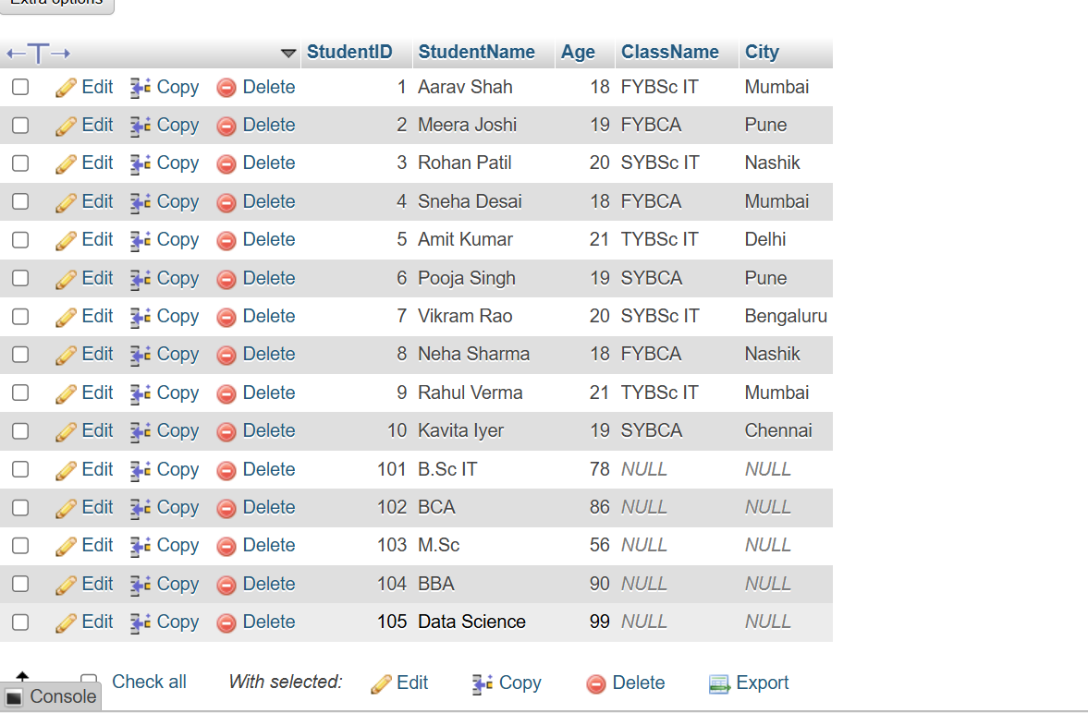

Q4) Create a table named Course with the following fields:
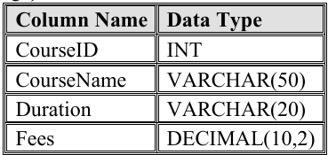
The program should:
1. Create the table.
2. Add a primary key on CourseID.
3. Insert at least 5 course records.
4. Display all course records.
Ans: Query:
CREATE TABLE Course (
CourseID INT PRIMARY KEY,
CourseName VARCHAR(50),
Duration VARCHAR(20),
Fees DECIMAL(10,2)
);
Output:
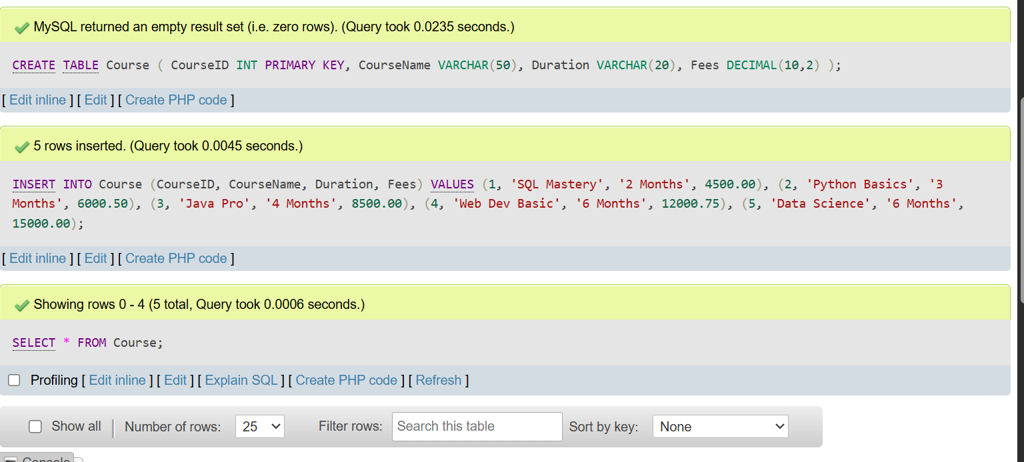
Q5) Write SQL queries to display only selected columns from the Student table. Display:
1. StudentName
2. ClassName
3. City Expected output should show only these three columns.
Ans: Query: SELECT StudentName, ClassName, City FROM student;
Output:
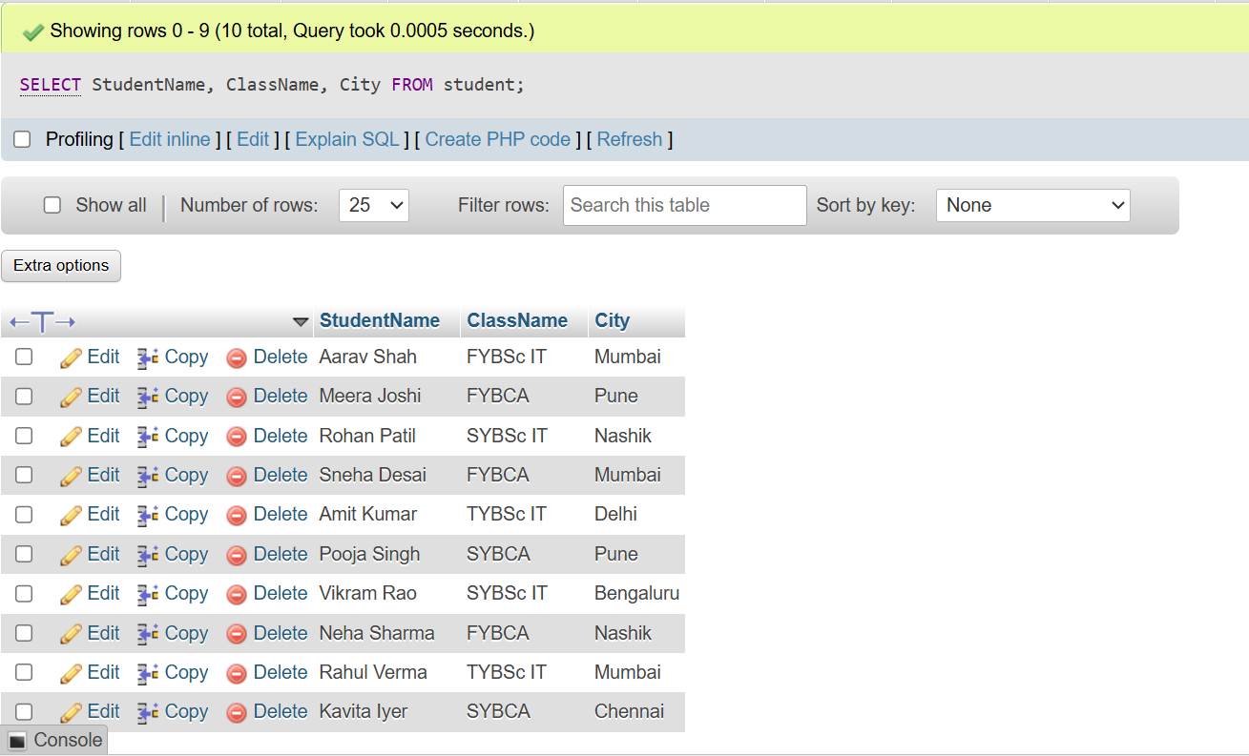

Q6) Write SQL commands to view the structure of the Student table. Use the suitable command according to the database environment:
Ans: Query:
-- MySQL Environment
DESC student;
#-- PostgreSQL Environment
#\d student
#-- SQLite Environment
#PRAGMA table_info(student);
Output:
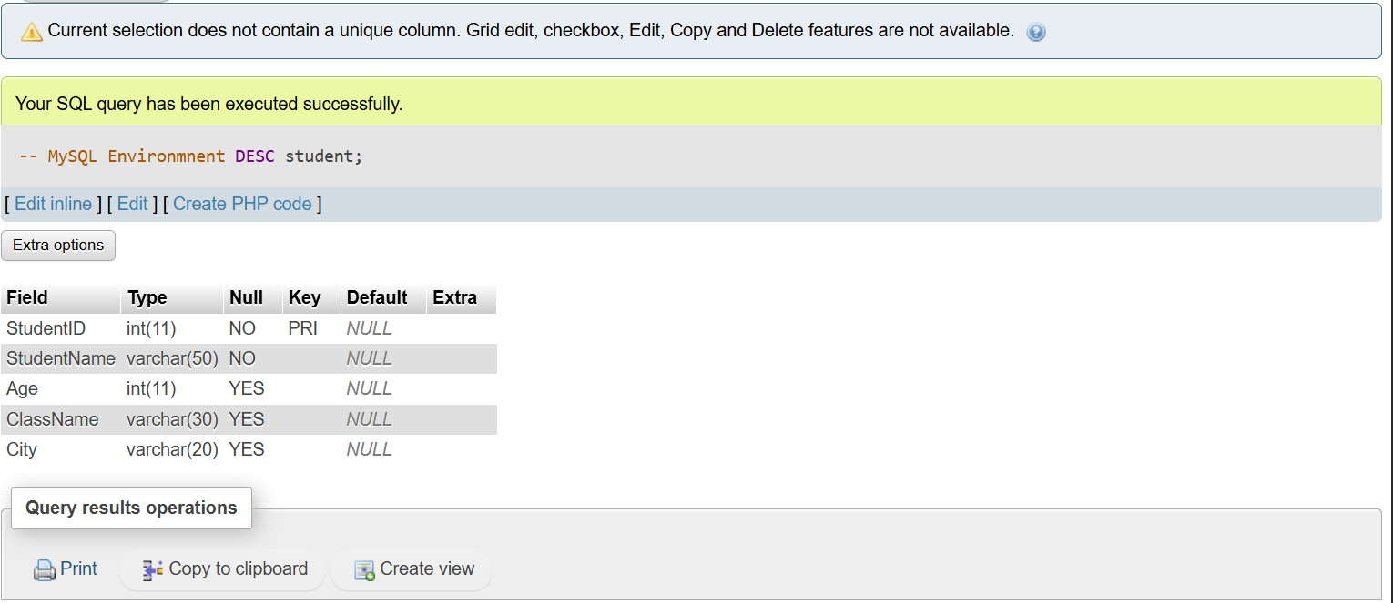

Q7) Prepare a CSV file named students.csv and import it into the Student table. The CSV file should contain:
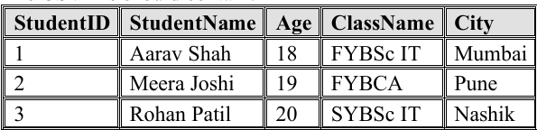
The task should include:
1. Creating a matching table.
2. Importing the CSV file.
3. Displaying imported records using SELECT.
Ans:Query: LOAD DATA INFILE
'C:/Users/SDBI/OneDrive/students.csv'
INTO TABLE student
FIELDS TERMINATED BY ','
ENCLOSED BY '"'
LINES TERMINATED BY '\n'
IGNORE 1 ROWS;

SELECT * FROM student;
Output:


Q8) Create a database named EmployeeDB and a table named Employee. The table should contain:
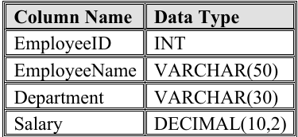
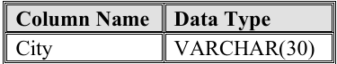
The program should:
1. Create the database.
2. Create the Employee table.
3. Insert 8 employee records.
4. Display all employee records.
Ans: Query:
CREATE DATABASE EmloyeeDB;
USE EmloyeeDB;

CREATE TABLE Employee (
EmployeeID INT PRIMARY KEY, EmployeeName VARCHAR(50),
department VARCHAR(30), Salary DECIMAL(10,2), City VARCHAR(30)
);

INSERT INTO Employee VALUES
(101, 'John Doe', 'IT', 75000.00, 'New York'),
(102, 'Jane Smith', 'HR', 65000.00, 'Chicago'),
(103, 'Sam Brown', 'Finance', 82000.00, 'Boston'),
(104, 'Lisa Ray', 'IT', 78000.00, 'Seattle'),
(105, 'Mark Lee', 'Sales', 60000.00, 'Austin'),
(106, 'Anna Kim', 'Marketing', 68000.00, 'Denver'),
(107, 'Paul Jay', 'Finance', 81880.00, 'Miami'),
(108, 'Emma Watson', 'HR', 66000.00, 'Dallas');

SELECT * FROM Employee;
Output:
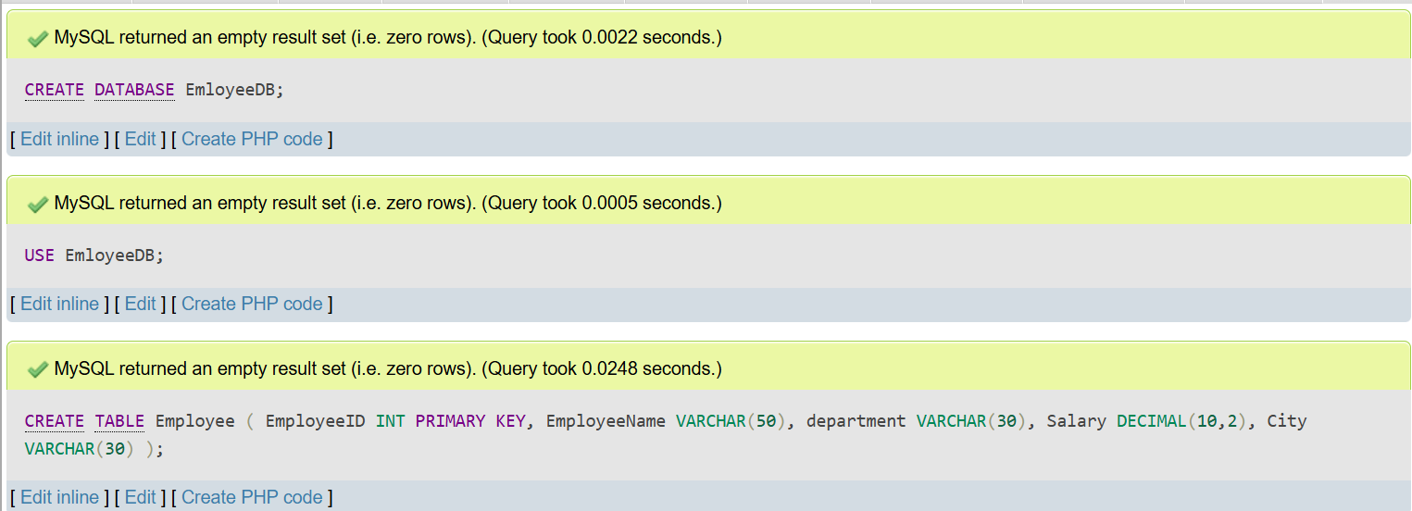
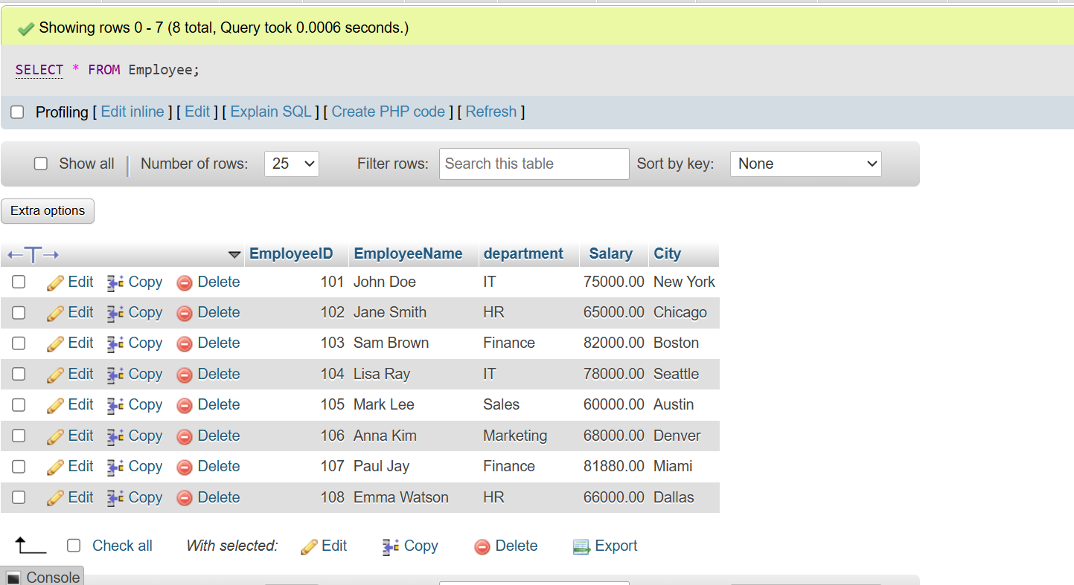

Q9) Write SQL queries to compare the difference between SELECT * and selecting specific columns. The task should include:
1. Query using SELECT * FROM Student;
2. Query using SELECT StudentName, City FROM Student;
3. Write two lines explaining the difference between both outputs.
Ans: Query: -- Query 1: The Wildcard Apporach
SELECT * FROM student;
-- Query2: The Specific Apporach
SELECT StudentName, City
FROM student;
Output:
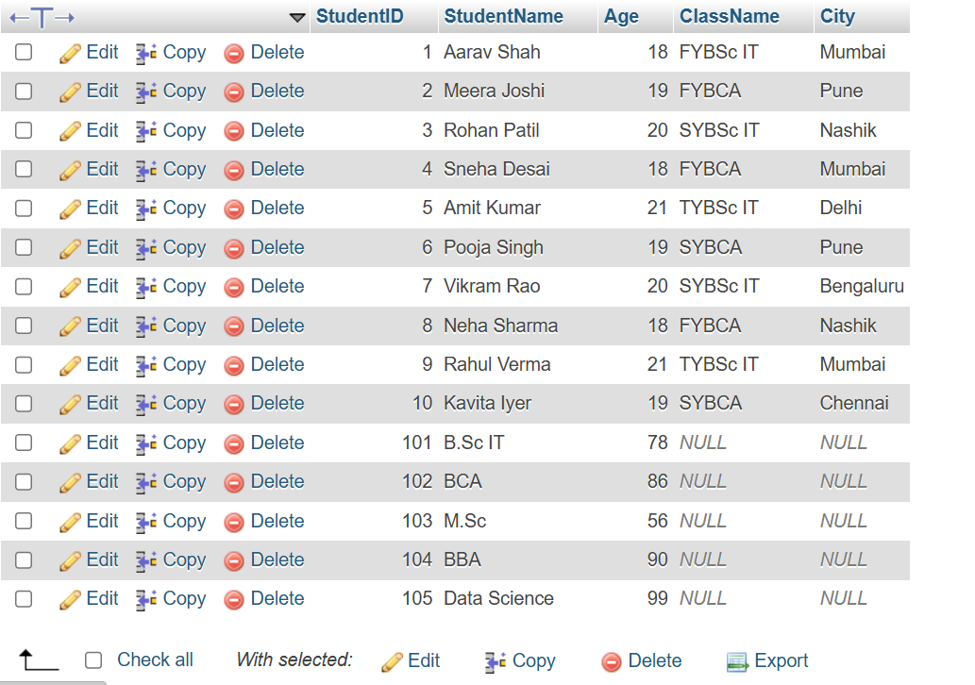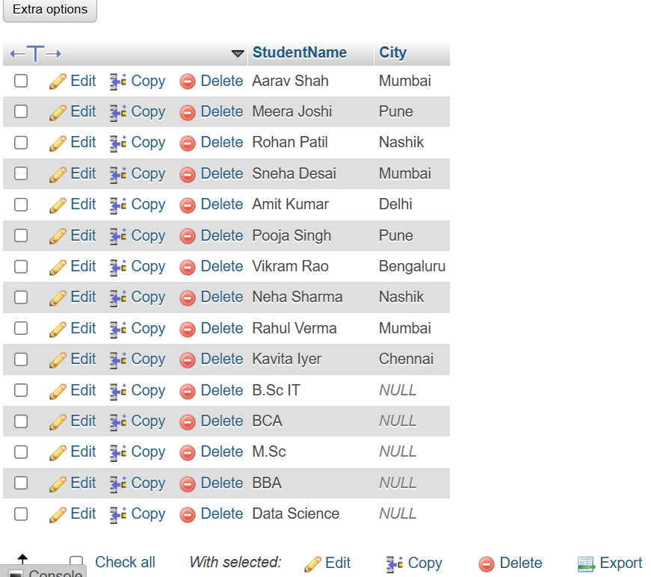
Difference between the outputs:
- SELECT * FROM Student; displays all columns and all records from the Student table.
- SELECT StudentName, City FROM Student; displays only the StudentName and City columns for all records.

Q10) Create a complete SQL script for a mini college database. The script should include:
1. Creating database MiniCollegeDB.
2. Creating tables Student, Course, and Faculty.
3. Adding suitable columns and data types.
4. Inserting at least 5 records in each table.
5. Displaying all records from each table.
6. Viewing the structure of each table.
Ans:
Output:
